Pupil Voice Science Autumn Term 2024
What do you know about Science?

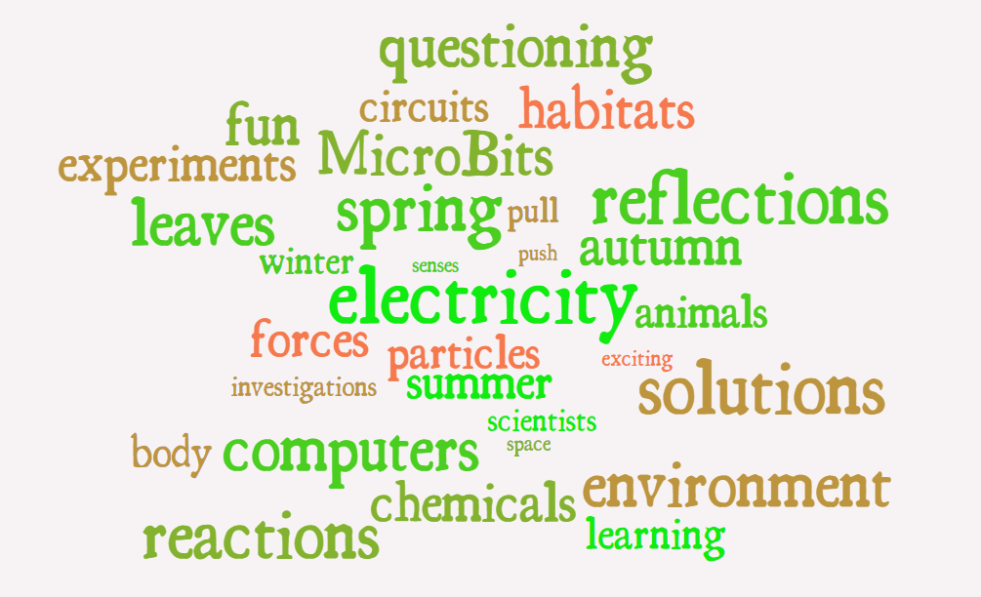

Why is Science important? Why do we learn about this subject?

KS1: Science is important because it teaches you important, fun stuff. You get to do fun activities. You learn about the world and about your body and it makes you smart. I really like science because you can learn loads of things and do experiments.
KS2: Scientists discover more; nothing would work without evolving Science. We need to learn about technology, survival and our surroundings (the world, the universe)! It is important that we investigate and experiment to understand and support our future.

What skills do you need to be a good Scientist?

KS1: You need: focus, concentration, listening ears, magnet eyes, putting your hand up and asking questions. You need to learn about everything, so you need to watch what is happening carefully.
KS2: You need a good understanding of maths; there is some maths involved. Teamwork, creativity, questioning, planning and purposeful investigations are important skills. You need patience when you are observing an experiment. Questioning is good when you get your results in.

What can you do now in Science that you couldn’t do before?

KS1 : I now know that animals make shelters in the cold weather. Squirrells hide their food so they have enough during the winter. There are four seasons: Autumn, Winter, Spring and Summer. Now, we are writing more independently in books. I didn’t know about animals and space. I love Space!
KS2: I understand how parachutes work and how different materials effect friction. I learnt a lot when we were experimenting with Changing Materials – how mixtures can be reversed (or not) and the best type of material for insulation. I now know about which type of material conducted the most heat. I know how the Moon orbits the Earth and the Earth orbits the Sun. It takes 365.25 days for us to travel around the sun!

Subject specific vocabulary enquiry:
KS1: Human senses –About hearing and eyesight. We learnt about the mouth, arm, legs (body parts). I know that our 5 senses are: tongue, ears, eyes, nose, hands. You can use your hands for sign language if someone cannot hear well.
Forces and Magnets – Magnets can stick together they have North and South poles. Two North’s push away but a North and South pole pull together.
Repulsion is when they don’t stick together and Attraction is when they stick together. Forces are a push and pull; like kicking a ball.

What piece of work were you most proud of and why?

My Science Week homework because I got to show it and present it in assembly.
My experiment on finding out what was the best material to insulate heat.
I liked finding out which food the Snail enjoyed the most – we did this as a class and it was so fun.

What went well in Science last year? | What could make Science better?
Variety of skills being taught within a unit.  Engaging and interesting lessons. | School trips for Science.  More experiments.

Which units from last year do you remember best? | Which are you not sure about or would like more support to help you remember?
Changing States and Materials.  Forces and Magnets.  Animals and Habitats. | I would like to know more about Scientists.  I like the questions in the Do Nows. They help me try to remember.

What helps you in Science?
Teachers.
Questioning and discussing our thoughts and ideas.
Experiments and working with others.
Videos.

From this, compare your pupil voice now with 2022/23…how has the subject progressed? What has changed? What trends are emerging for this year? What insight does this pupil voice give you and what will you do as a result of it?
From observations, book-looks, pupil voice and golden threads in staff meetings, it is clear that children are enjoying Science. They all enjoyed and engaged with Science week last year and we had an excellent amount of Home Learning bought to present in assembly. During all pupil voice meetings, their was a passion and engagement for the subject.
Going forward, we must continue to foster their curiosity and love for Science. We must look at new and inventive ways of getting prior knowledge to stick. Use of songs, questioning and using our assessments to re-visit any misconceptions or gaps in their understanding. Continue to get workshops in and Science trips booked!

