Pupil Voice Maths Autumn Term 2024
What do you know about Maths?

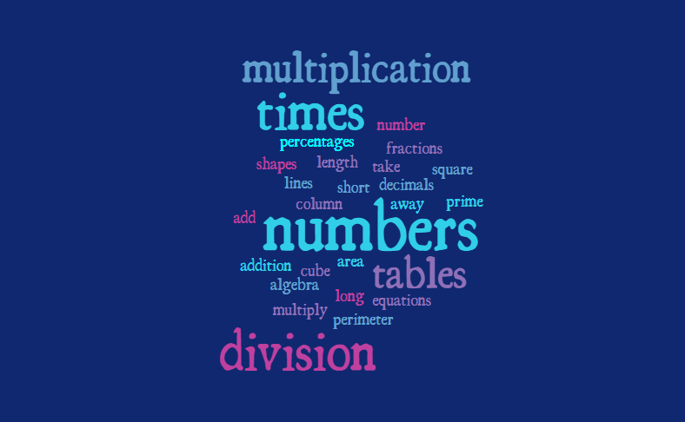
“I know all about numbers and number lines…” Year 1

“Solving equations can take many steps and you have to think about the order…” Year 6
“I know that you can’t learn maths in the click of a finger…” Year 4

Why is Maths important? Why do we learn about Maths?

Key Stage 1: So that we can be smart
You can count things; to use in everyday life activities; maths comes up in everyday life; good at learning numbers
Lower KS2: You need it when you’re building (making buildings); in everyday life like time; you use it when you’re older; to tell the time; to know how to count money; time/ how to read a clock; Roman numerals
Upper Key Stage 2: To help solve things like shopping and finance; it comes up in business; you can add money to work things out; it builds knowledge on what we already know

What skills do you need to be a good Mathematician?

Key Stage 1: To be good at counting, knowledge of multiplication, patience to solve problems
Lower KS2: To know all your times tables; to keep trying; show your working out
Upper Key Stage 2: Resilience to try again when you get something wrong; prime numbers, using decimals; multiplying bigger numbers by two-digit numbers; clear on methods to use (efficient methods for the four operations)

What can you do now in Maths that you couldn’t do before?

Key Stage 1: Count to 150, 3 times table, times tables, division, reading solving questions
Lower KS2: Division, multiplication, 8 times table, 7 times table, harder division; 3 times table;
Upper Key Stage 2: Convert fractions into decimals and percentages; turn decimals into percentages; find percentages and fractions of amounts

What went well in Maths last year? | What could make Maths better?
Counting  Multiplying fractions  Fractions  Converting mixed numbers to improper fractions  Multiplying 2 digit by 2 digit  Short division | Revise length, height and time  Revision and practicing skills  Showing my working out

Which units from last year do you remember best? | Which are you not sure about or would like more support to help you remember?
Counting and numbers  Patterns  Addition and Subtraction  Place value  Shape  Money  Fractions  Decimals and Percentages  Multiplication and Division | Length, height and time  Fractions  Time  Length and perimeter  Decimals  Perimeter and Area

What helps you in Maths?
Revision
Patience
Apparatus
Time to work it out and not rush

From this, compare your pupil voice now with 2022/23…how has the subject progressed? What has changed? What trends are emerging for this year? What insight does this pupil voice give you and what will you do as a result of it?
Revision and spaced retrieval are valued and so Do Nows and Maths Meetings are an important part of what we do - continue to build on this.

Frequent re-visiting of summer term content stops it becoming forgotten during the year (matches maths report findings).

Feedback to staff about the value from the children’s perspective.

More children are able to recall some learning from previous year this time than last.

Continue to embed use of language in all we do – strong language links between areas of maths consolidates learning and underpins building blocks.

