Art and Design

“Every child is an artist!" – Pablo Picasso

At St Andrew’s Primary School, we equip our pupils with the knowledge and skills to experiment, invent and create their own works of art, craft and design. As pupils progress, they are encouraged to think critically and develop a more rigorous understanding of art and design. We want them to appreciate how art and design reflects and shapes our history, and contributes to the culture, creativity and wealth of our nation and other nations across the world.

What does out approach to Art look like in the classroom?
Our Art and Design curriculum from EYFS to year 6, provides a clear and comprehensive scheme of work, delivered through Cornerstones projects, that shows a progression of skills, knowledge and understanding which inspires creativity and supports and challenges all learners.
Every year we have an artist in residence giving the children an opportunity to develop their skills and work alongside a practising artist.

In the EYFS, pupils explore, use and refine a variety of artistic techniques to express their feelings and ideas. Alongside specific skill-based teaching, continuous provision gives pupils access to all resources and opportunities, allowing them to develop their knowledge, skills and understanding at their own pace and interest.

Pupils in KS1 are taught to be imaginative, expressive and creative developing their art, craft and design skills as part of a continuous learning process. Sketchbooks are introduced and they learn how to use a range of drawing, painting and sculpture techniques to explore colour, pattern, texture, line, shape and form. Pupils are exposed to a range of artists work and encouraged to describe similarities and differences and make links to their own work.

In Keys Stage 2 Pupils are taught to develop and improve their mastery of techniques, including their control and their use of materials, with creativity, experimentation and an increasing awareness of different kinds of art, craft and design. They use sketch books to record their observations, to review and revisit ideas using the language of art, craft and design. Pupils learn about great artists, craft makers and designers, and understand the historical and cultural development of their art forms.
.

How do we measure success in Art?
Through Cornerstones planned progression of artistic skills, knowledge and understanding, pupils are able to develop and build on their mastery of the Art and Design process. At the end of each project, pupils have the opportunity to complete an ‘innovate challenge’, either independently or with others, to apply the skills and knowledge explored in that unit. Teachers are then able to observe how successfully pupils can use, apply and problem solve in creative and imaginative ways. Pupils will be assessed formatively at the end of each lesson and summatively at the end of each unit of work. Teachers will assess if pupils are working below expected, at the expected level or working at greater depth against the Art and Design National Curriculum objectives. Pupils work is celebrated through engaging displays and project drop-ins for parents.

Evidence of impact is gathered and monitored through a variety of methods.

- Class observation of teaching and learning
- Monitoring of planning
- Gathering of pupil voice data
- Sketchbook looks to show the art and design process
- Whole school portfolios of work
- Displays

Art and Design Whole School Overview
Class |  | Y Group | Term 1 | Term 2 | Term 3
2023/24
Cole |  | YR&1 | Funny Faces and Fabulous Creatures  This project teaches children about the concept of the portrait and how the collage technique can be used to make a portrait. | Street View  This project teaches children about artwork depicting streets and buildings and focuses on the work of the American pop artist, James Rizzi. They explore his use of colour and form and layering techniques. | Rain and Sunrays  This project teaches children about collagraph printing, including how to develop a motif to make single and repeated prints.
Innovate Challenge |  |  | To make a self- portrait using collage techniques. | To make a colourful, 3D picture of buildings from the local landscape in the style of James Rizzi. | To make a collagraph print inspired by the weather.
Brown |  | Y2&3 | Prehistoric Pots  This project teaches children about Bell Beaker pottery. It allows the children to explore different clay techniques, which they use to make and decorate a Bell Beaker-style pot. | Rain and Sunrays  This project teaches children about collagraph and block printing, including how to develop a motif to make single and repeated prints. Using different colour ways. | People and Places  This project teaches children about the genre of figure drawing. They study the figure drawings and urban landscapes of the artist LS Lowry.
Innovate Challenge |  |  | To make a bell beaker style pot using a combination of pinch, coil and pattern techniques | To make a collagraph print back ground overlaid with a block print. | To use sketches and studies to paint a piece called ‘Coming out of school.’
Kolisi | Y3&4 |  | Prehistoric Pots  This project teaches children about Bell Beaker pottery. It allows the children to explore different clay techniques, which they use to make and decorate a Bell Beaker-style pot. | Beautiful Botanics  This project teaches children about the genre of botanical art. They create prints and beautiful and detailed botanical paintings of fruit and flowers. | Warp and Weft  This project teaches children about the artform of weaving and how it has developed over time, including the materials and techniques required to create woven patterns and products.
Innovate Challenge |  |  | To make a bell beaker style pot using a combination of pinch, coil and pattern techniques. | To paint a detailed botanical colour water study. | To use their weaving skills and experience to create woven wall hangings.
Nadim  Biles |  | Y4&5  Y5 | Expression  This project teaches children about the Expressionist art movement and the 'Father of Expressionism', Edvard Munch. They explore different ways to portray feelings and emotions in art. | Nature’s Art  This project teaches children about the genre of land art. They work outdoors to sketch natural forms and explore the sculptural potential of natural materials before working collaboratively to create land art installations. | Bees, Beatles and Butterflies  This project teaches children about sketchbooks, observational drawing, mixed media collage and Pop Art. They consolidate their learning to make a final piece of artwork inspired by bees, beetles or butterflies
Innovate Challenge |  |  | To paint an expressionist self-portrait. | To create a land art installation. | To develop a final piece of mixed media art work inspired by their studies.
Farah Y6 |  |  | Expression  This project teaches children about the Expressionist art movement and the 'Father of Expressionism', Edvard Munch. They explore different ways to portray feelings and emotions in art. | Line, Light and Shadows  This project teaches children about the visual qualities of line, light and shadow. They explore the work of Pablo Picasso and Rembrandt and are introduced to a range of shading techniques. | Taotie  This project teaches children about the significance and art of the taotie motif, including ancient and contemporary casting methods.
Innovate Challenge |  |  | To paint an expressionist self-portrait. | To take black and white photographs and use pencil, pen and ink wash to create a shaded drawing. | To make Taotie reliefs.

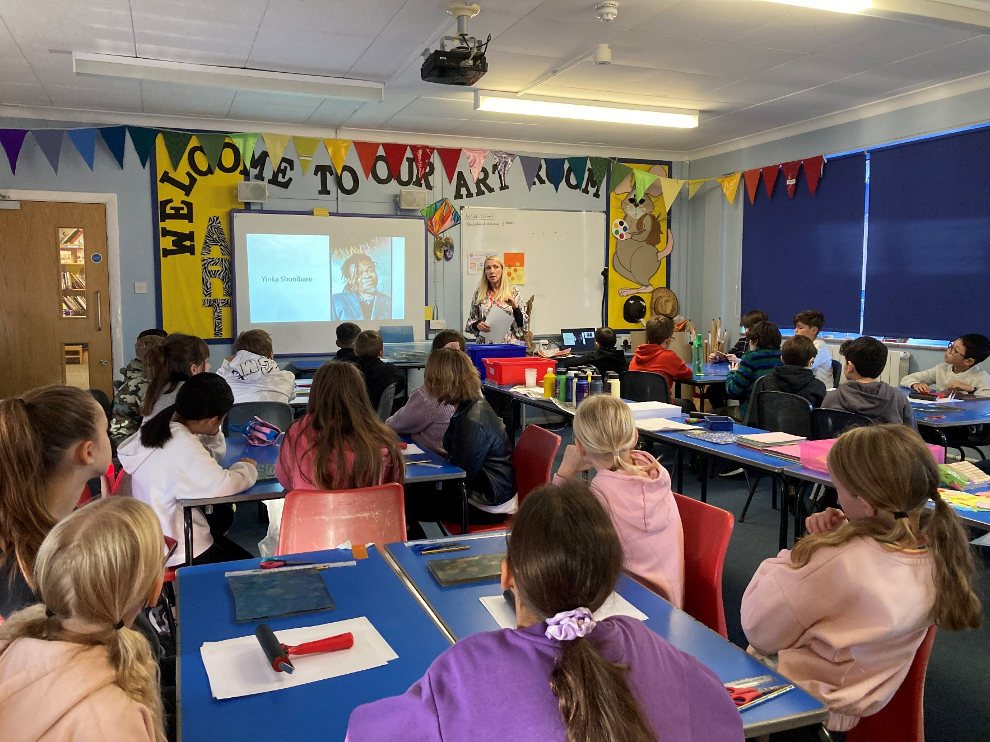

‘

Printing workshop with artist in residence, Julie Hoyle.

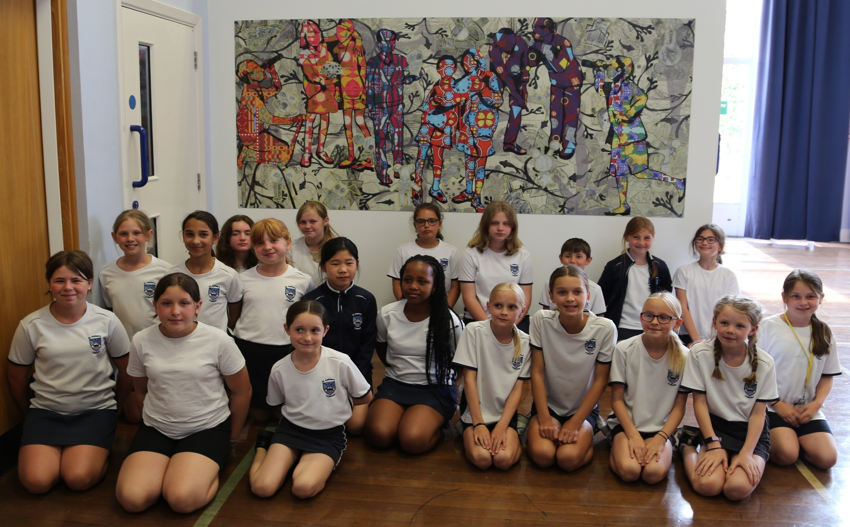

‘Quest’ a collaborative art installation between contemporary printmaker and artist, Julie Hoyle and Year 6 pupils.

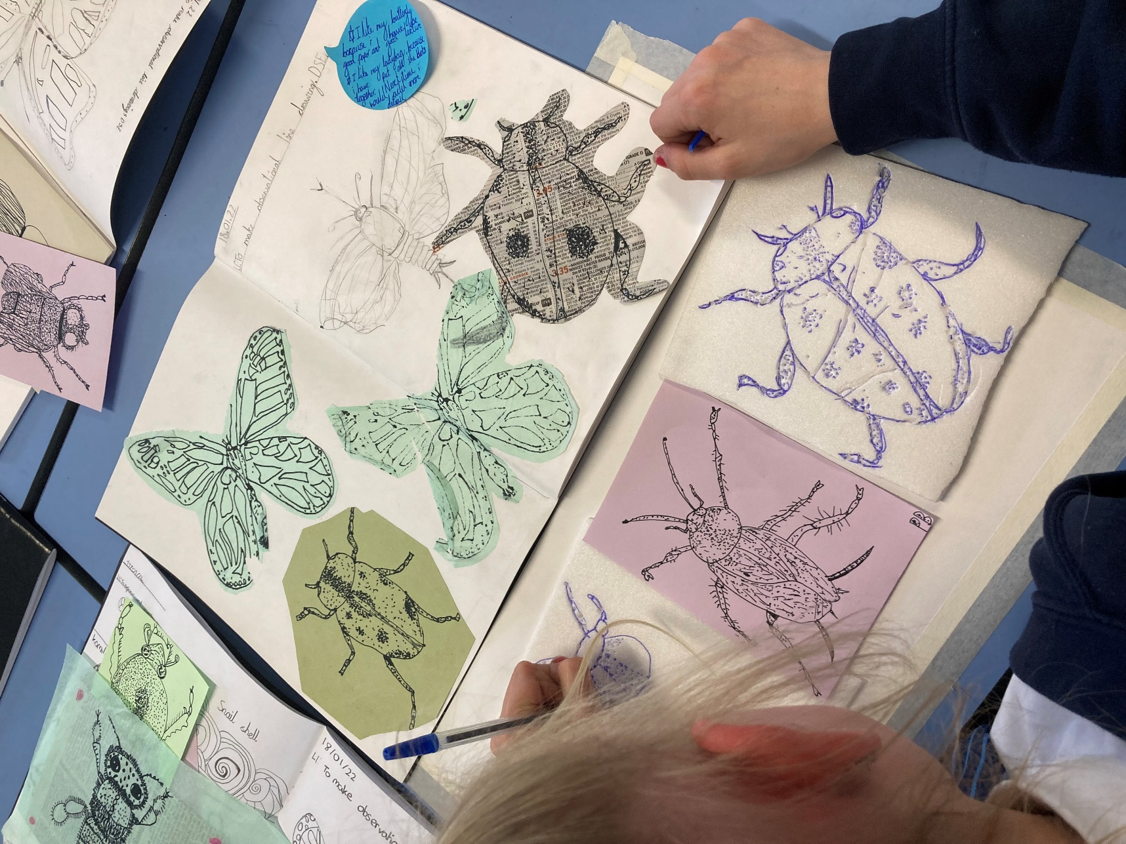

Year 5 sketchbooks.
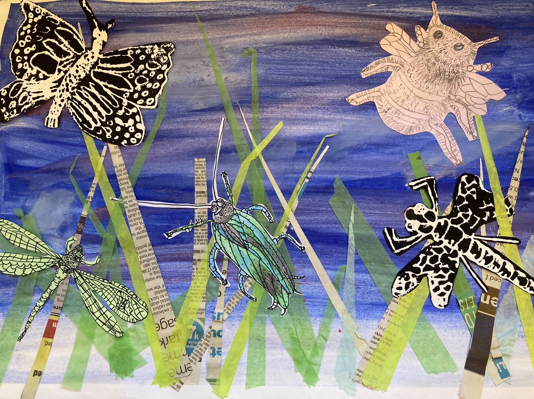

Year 5 mixed media art work.
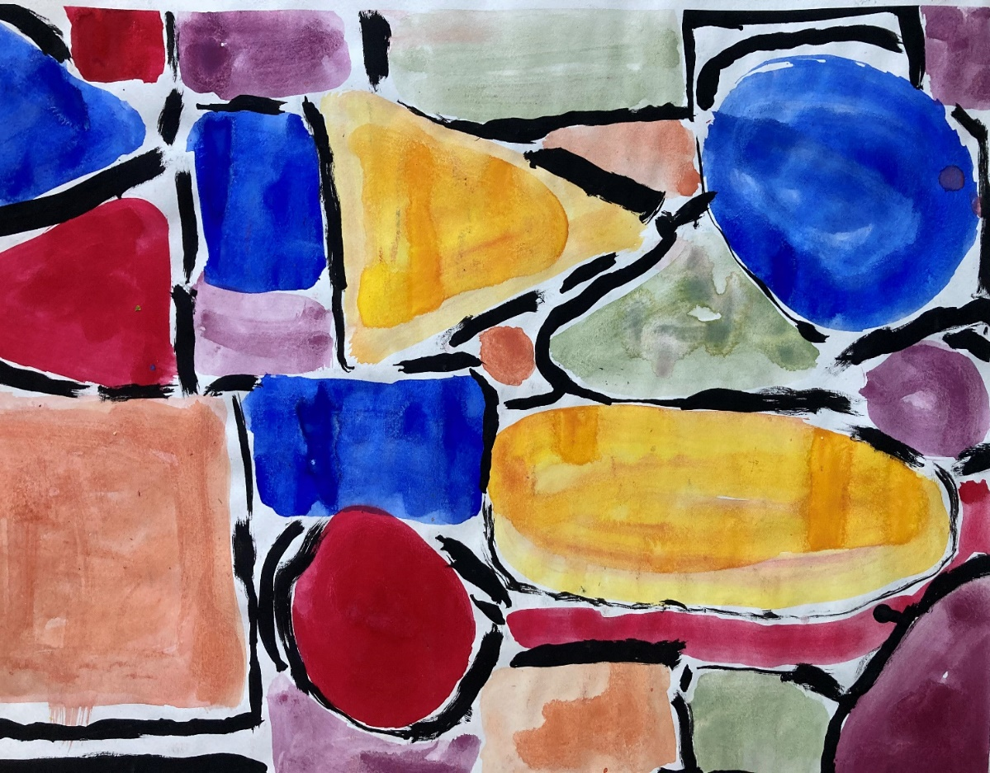
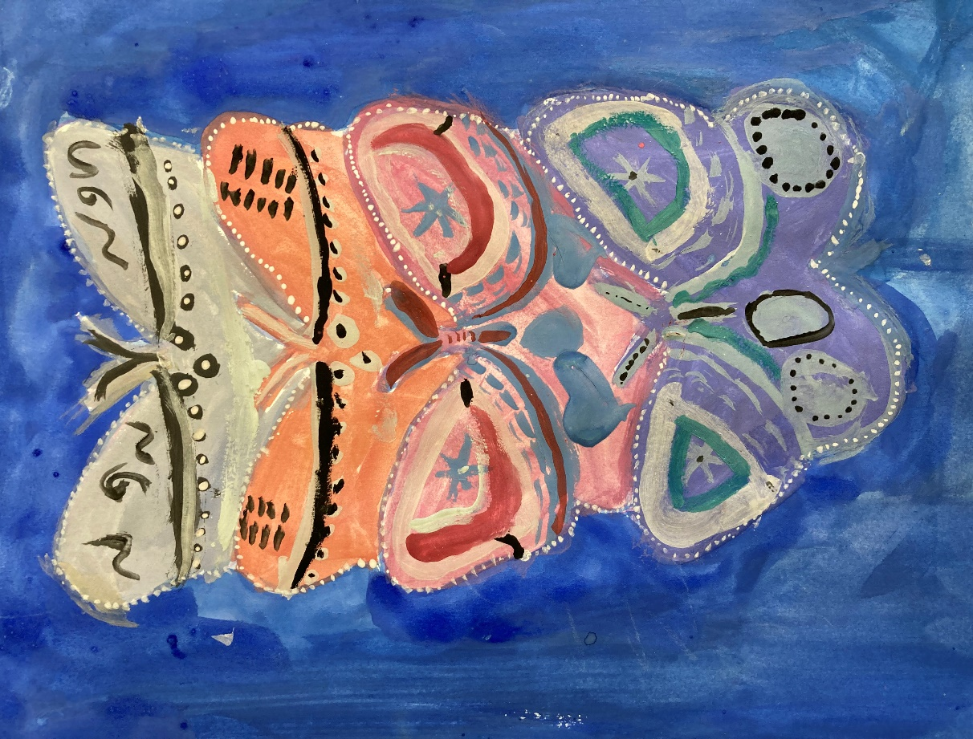

Year 2 and year 4 exploring colour.
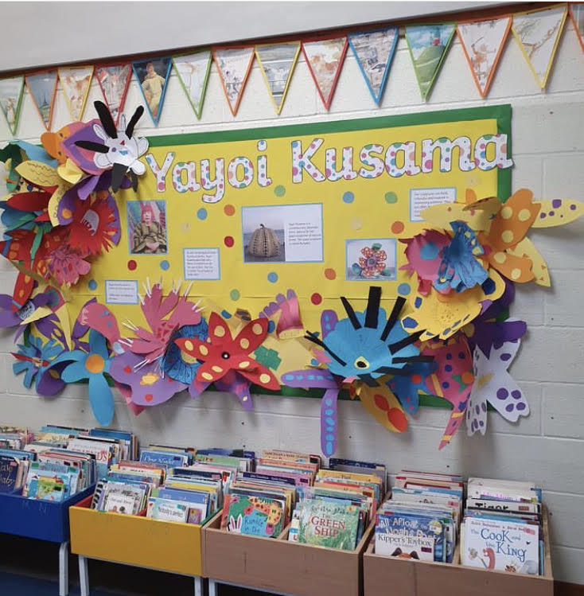

EYFS
Year 2 and 3 paper sculptures.

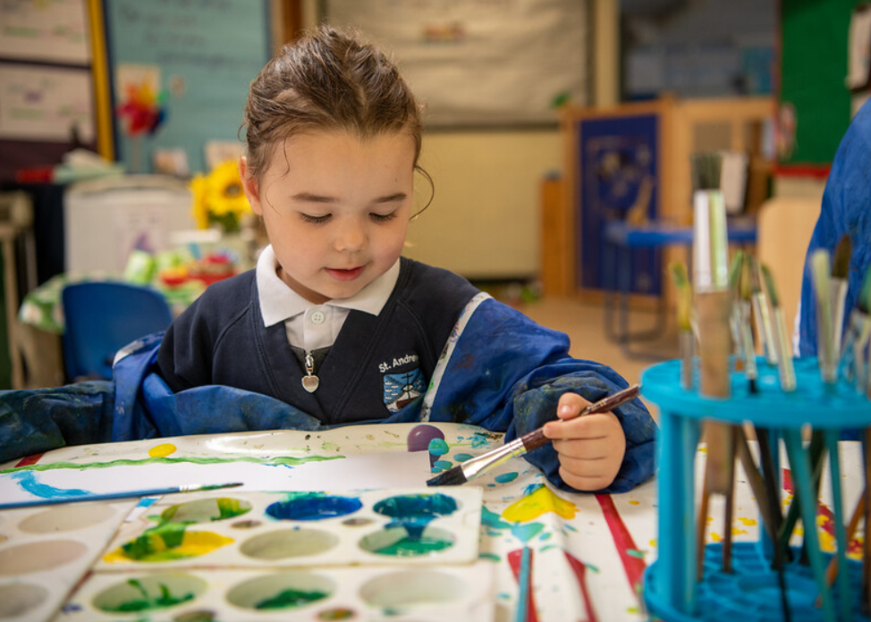

EYFS

