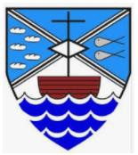
Jigsaw PSHE Changing Me – Year 6

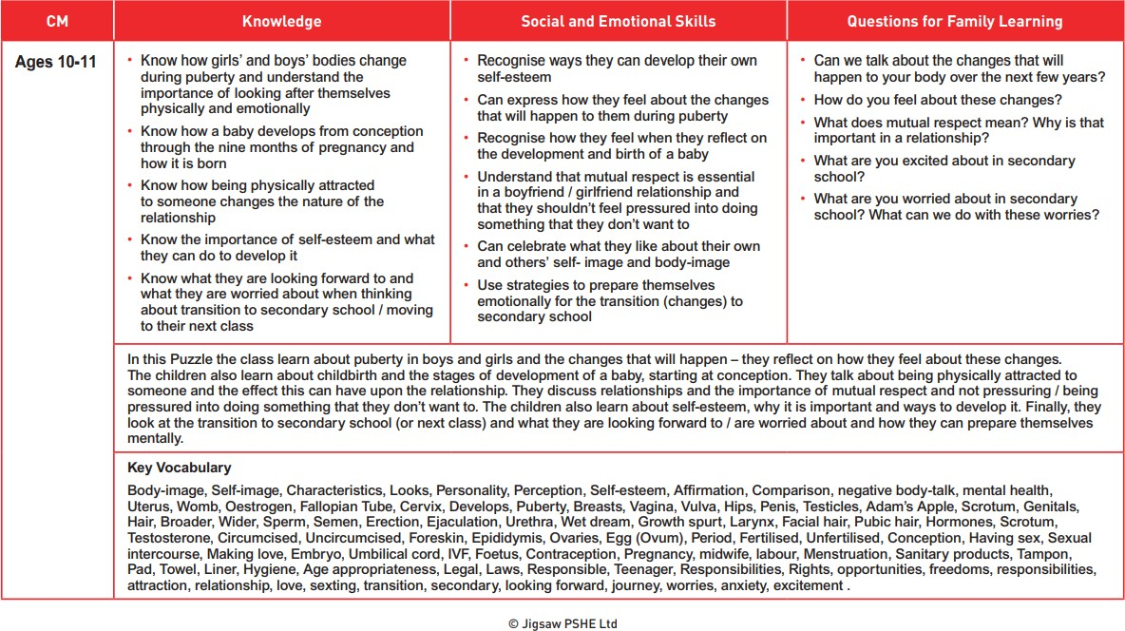The vocabulary used in PSHE during the ‘Changing Me unit’ in the Summer term.

NB – We do not intend to teach about circumcision. This term will only be mentioned if a child asks a direct question.

