
Jigsaw PSHE Changing Me – Year 5
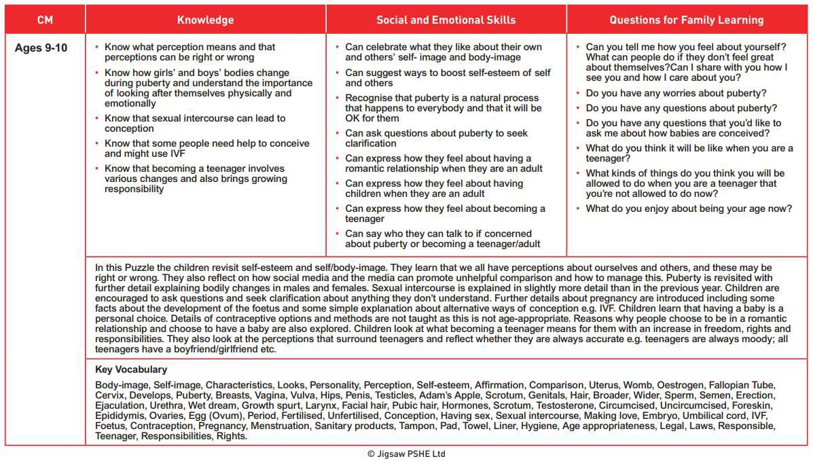The vocabulary used in PSHE during the ‘Changing Me unit’ in the Summer term.

NB – We do not intend to teach about circumcision or epididymis. These terms will only be mentioned if a child asks a direct question.

