Jigsaw PSHE Changing Me – Year 2
The vocabulary used in PSHE during our ‘Changing Me unit’ in Summer term 2

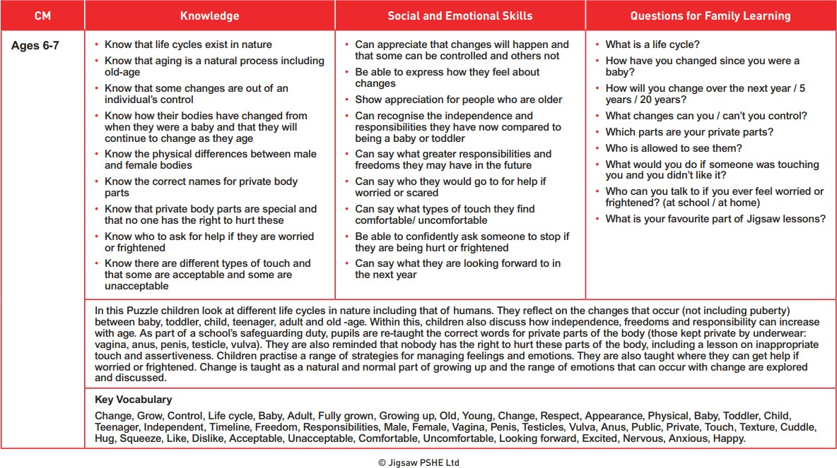
Breasts, Nipples, Bottom

