Jigsaw PSHE Changing Me – Year 3
The vocabulary used in PSHEs during the ‘Changing Me unit’ during the Summer term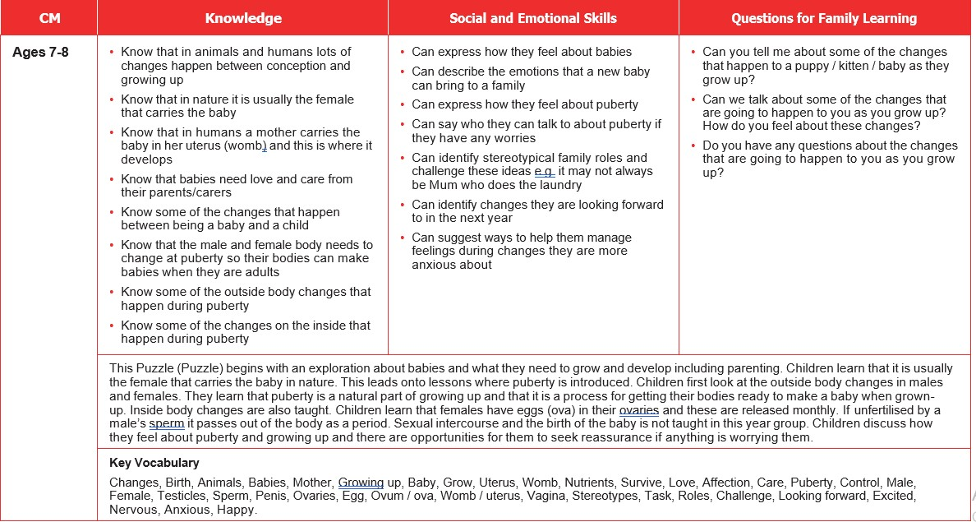

This puzzle begins with an exploration about babies and what they need to grow and develop including parenting. Children learn that it is usually the female that carries the baby in nature. This leads to lessons where the children use scientific vocabulary to name the body parts of males and females and the beginning of puberty and body changes are introduced. The children look at some of the outside body changes and learn that puberty is a natural part of growing up. Children discuss how they feel about puberty and growing up and there are opportunities for them to seek reassurance if anything is worrying them.
Key Vocabulary: Changes, Birth, Animals, Babies, Mother, Growing up, Baby, Grow, Womb/ Uterus, Nutrients, Nutrients, Survive, Love, Affection, Puberty, Control, Life cycle, Adult, Fully grown, Growing up, Old, Young, Change, Respect, Appearance, Physical, Baby, Toddler, Child, Teenager, Independent, Timeline, Freedom, Responsibilities, Male, Female, Vagina, Penis, Testicles, Vulva, Anus, Public, Private, Touch, Texture, Cuddle,Hug, Squeeze, Like, Dislike, Acceptable, Unacceptable, Comfortable, Uncomfortable, Looking forward, Excited, Nervous, Anxious, Happy, Stereo types, Task, Roles.

